Learn While You Sleep

1. TItle and Intro

1.1 Home Page
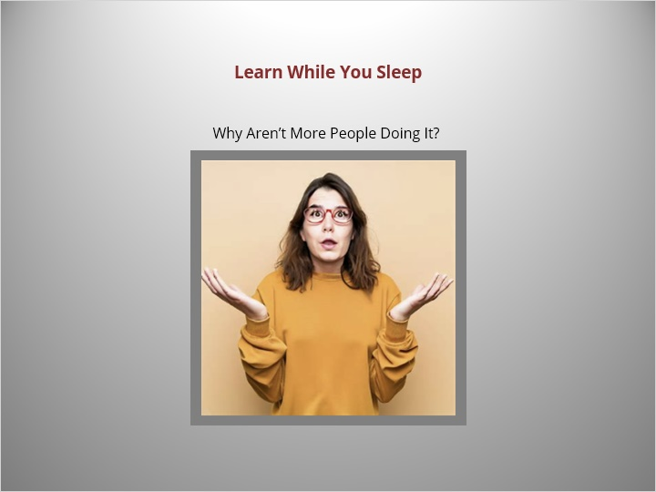

1.2 Intro
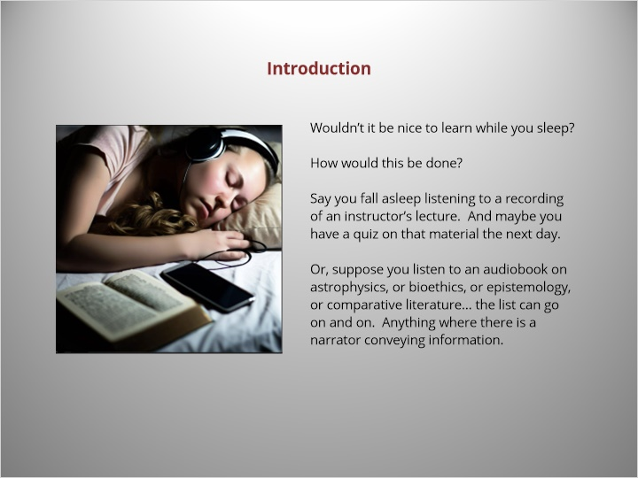

1.3 Intro (cont'd)
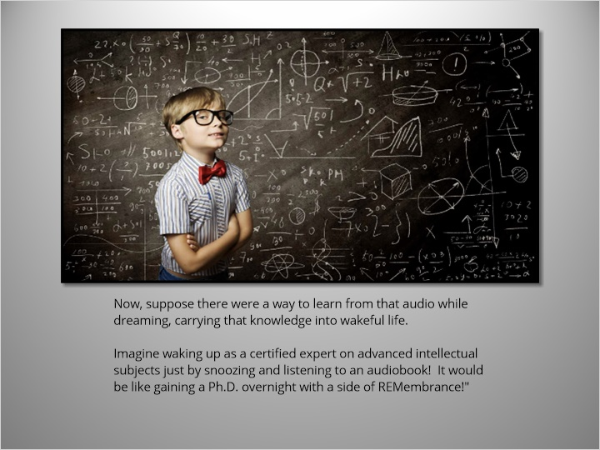

1.4 About
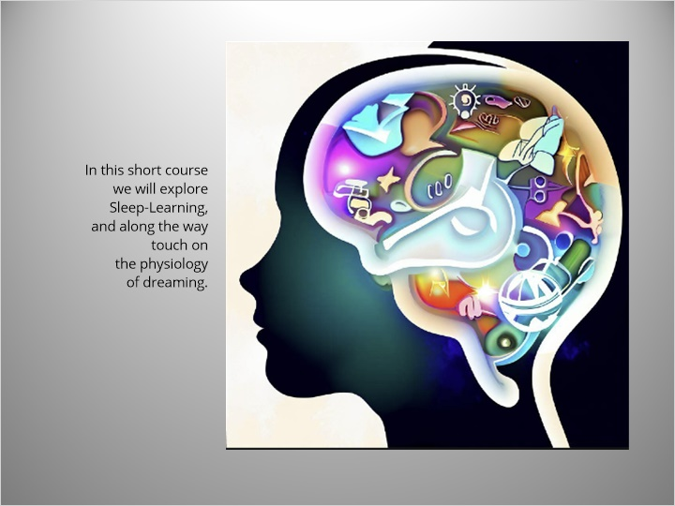

1.5 Objectives
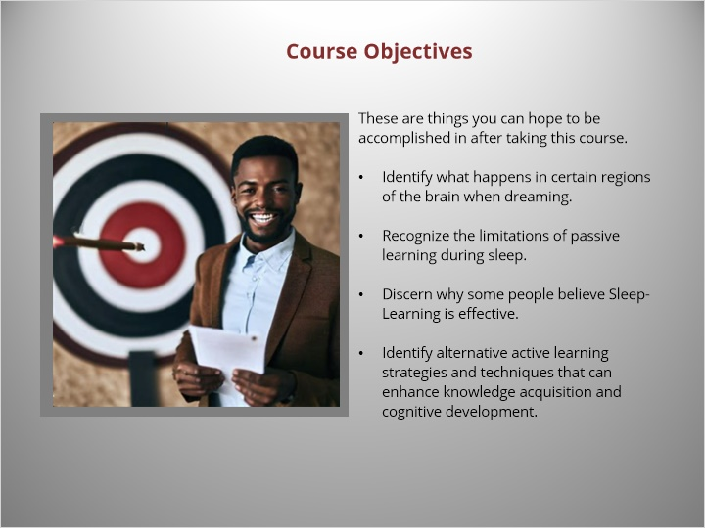
Notes:

1.6 Part 1, Part 2
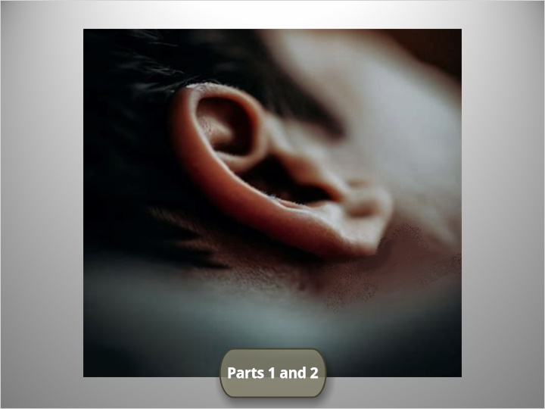

1.7 Part 3
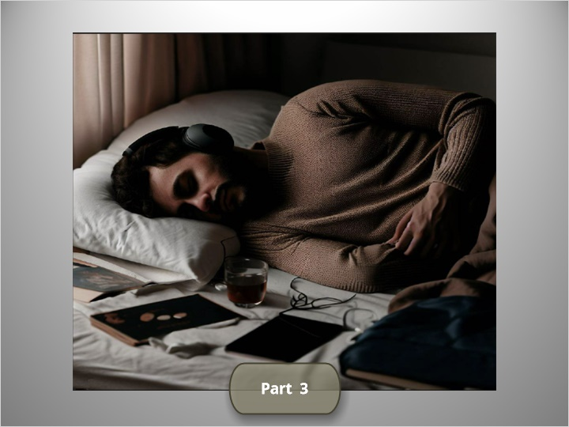

1.8 Wrap-up
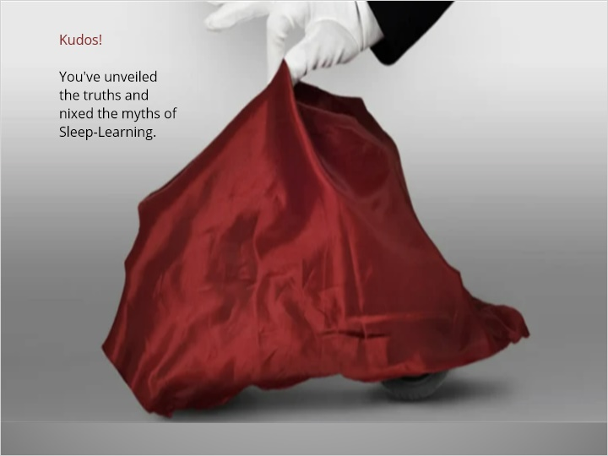

1.9 Quiz Intro
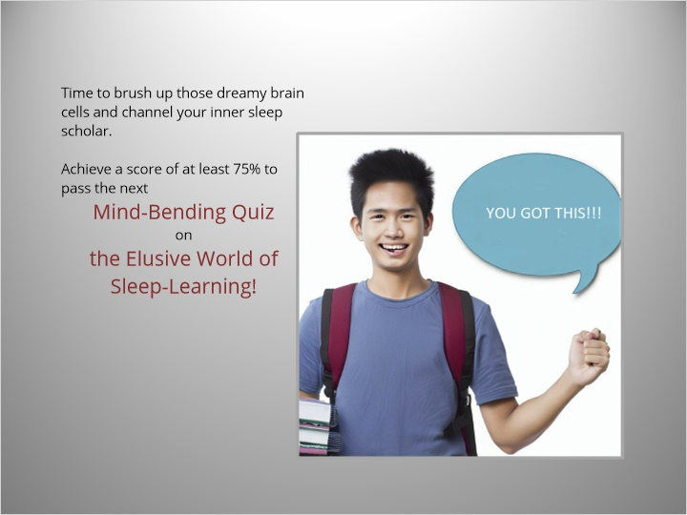

1.10 Quiz
Draw 4 questions randomly from Question Bank 1

1.11 Quiz Results
(Results Slide, 0 points, 1 attempt permitted)
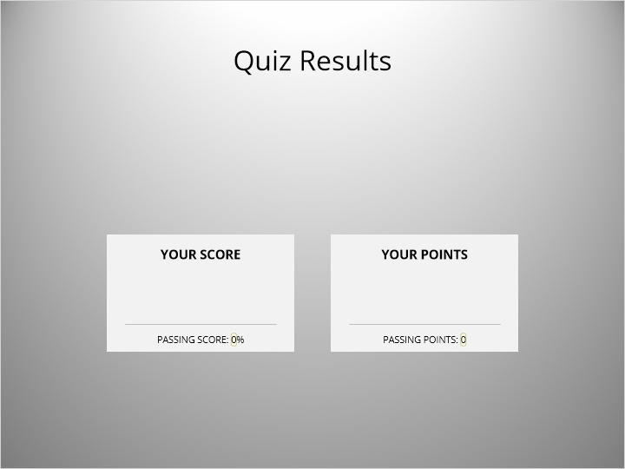

Results for
1.10 Quiz

Result slide properties
Passing  Score | 75%

Success (Slide Layer)
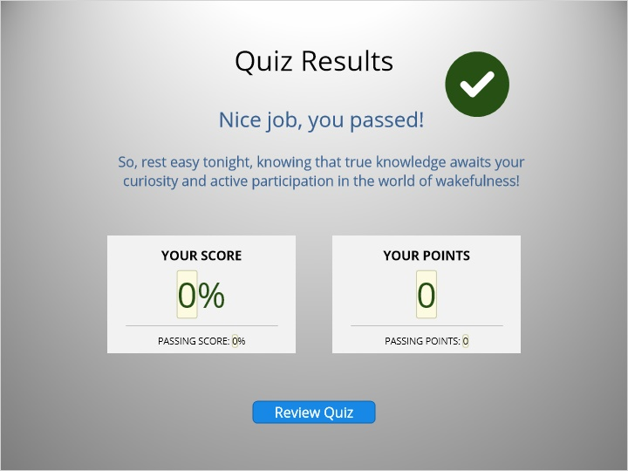

Failure (Slide Layer)
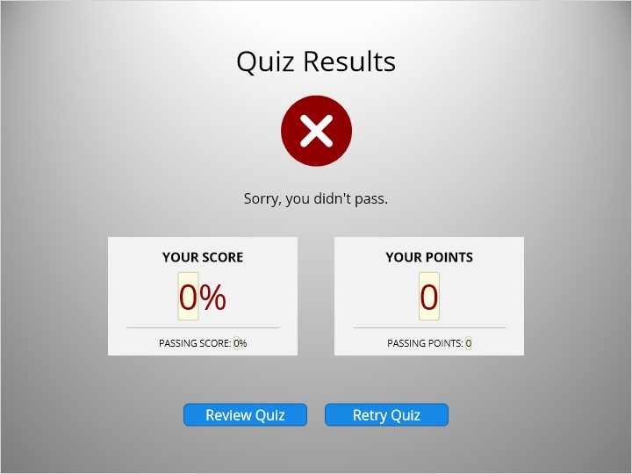

1. Question Bank 1

Q1.1 Auditory stimuli during sleep have been proven to be a highly effective method for learning and knowledge retention.
(True/False, 10 points, unlimited attempts permitted)
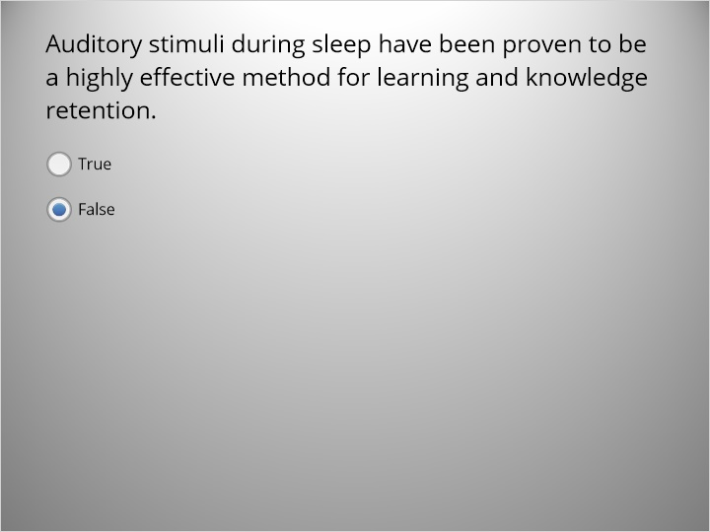
Correct | Choice
 | True
X | False

Feedback when correct:
That's right! You selected the correct response.
Feedback when incorrect:
You did not select the correct response.

Correct (Slide Layer)
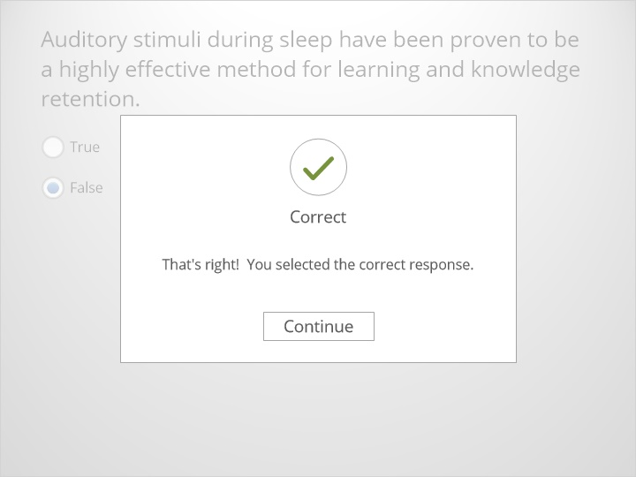

Incorrect (Slide Layer)
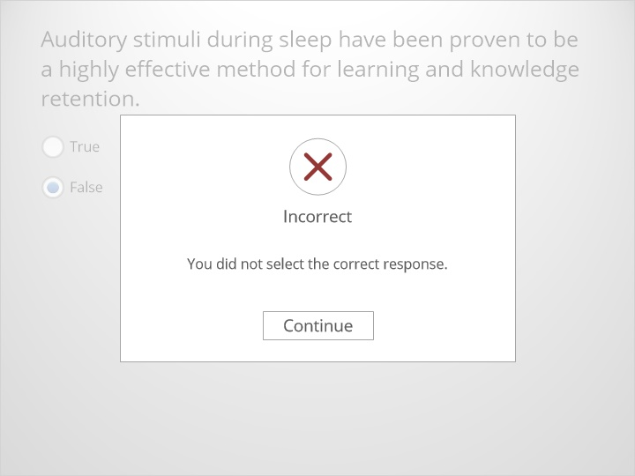

Q1.2 What is the primary function of sleep regarding information processing and memory?
(Multiple Response, 10 points, 1 attempt permitted)
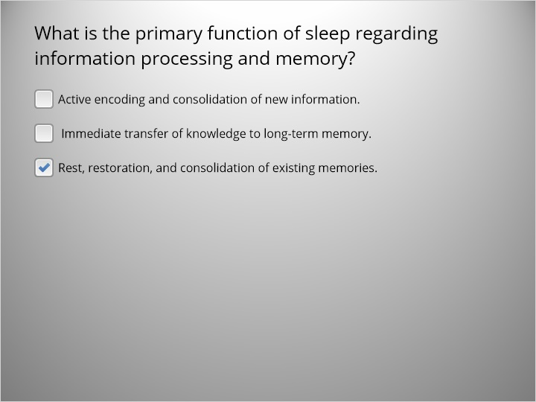
Correct | Choice
 | Active encoding and consolidation of new information.
 | Immediate transfer of knowledge to long-term memory.
X | Rest, restoration, and consolidation of existing memories.

Feedback when correct:
That's right! You selected the correct response.
Feedback when incorrect:
You did not select the correct response.

Correct (Slide Layer)
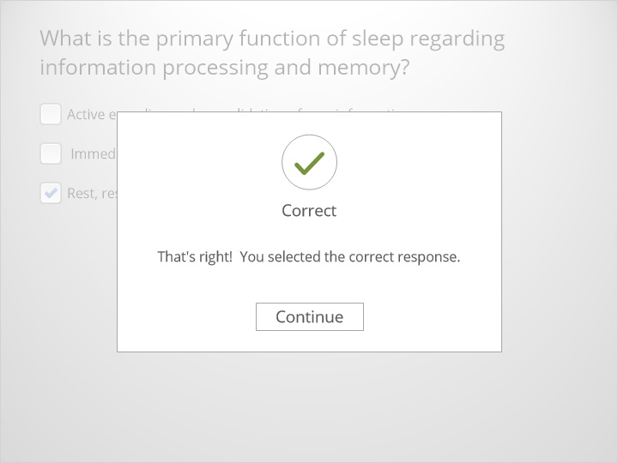

Incorrect (Slide Layer)
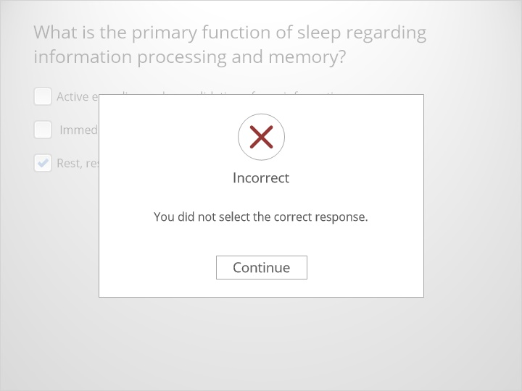

Q1.3 The brain's capacity for focused learning and comprehension is significantly reduced during sleep, making it difficult to actively process and retain information from auditory stimuli.
(True/False, 10 points, 1 attempt permitted)
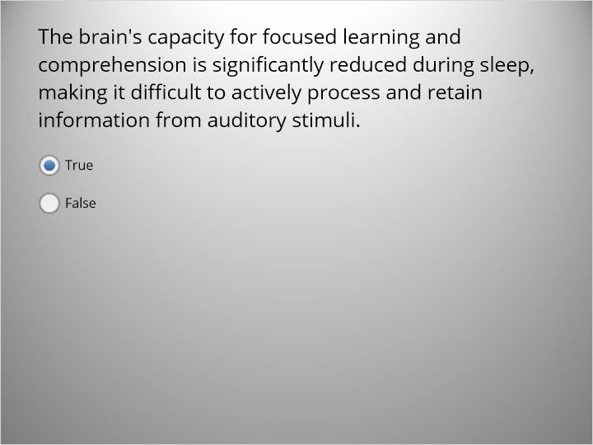
Correct | Choice
X | True
 | False

Feedback when correct:
That's right! You selected the correct response.
Feedback when incorrect:
You did not select the correct response.

Correct (Slide Layer)
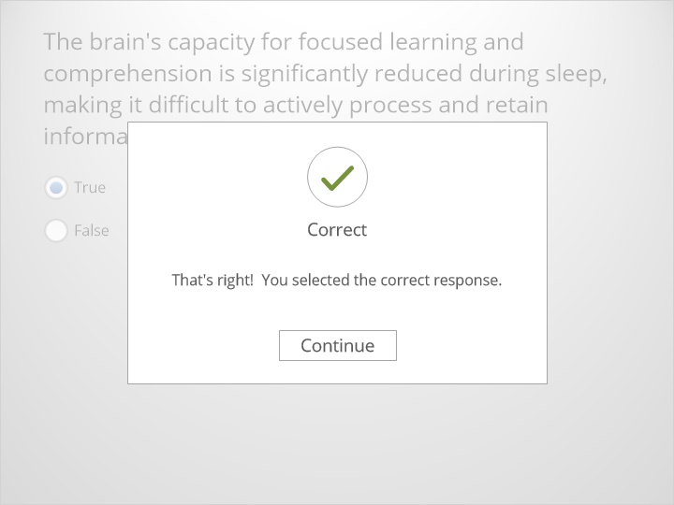

Incorrect (Slide Layer)
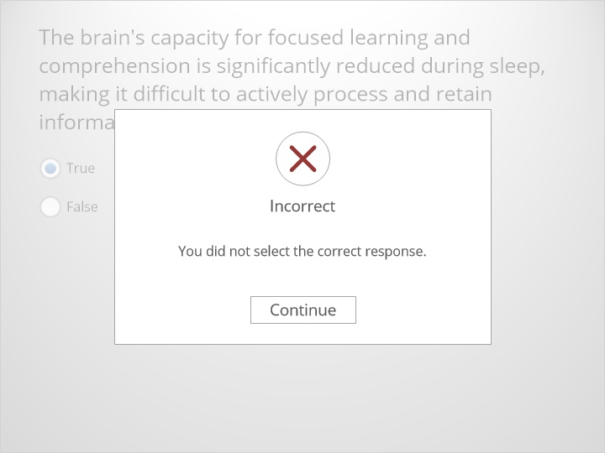

Q1.4 Some people still believe in the effectiveness of auditory stimuli during sleep due to confirmation bias.
(True/False, 10 points, 1 attempt permitted)
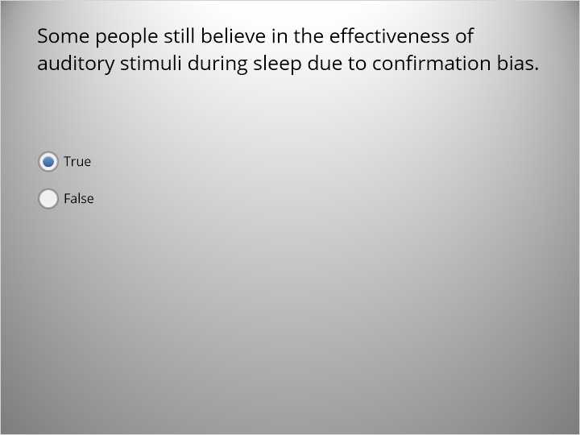
Correct | Choice
X | True
 | False

Feedback when correct:
That's right! You selected the correct response.
Feedback when incorrect:
You did not select the correct response.

Correct (Slide Layer)
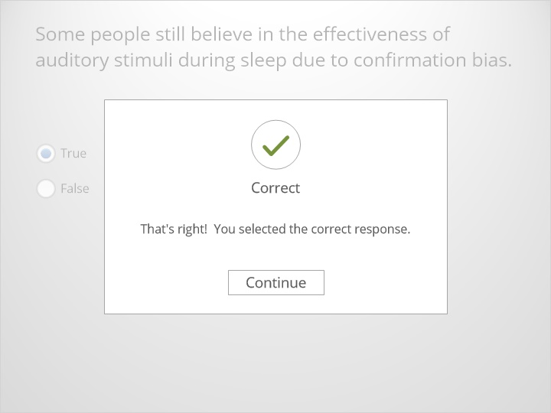

Incorrect (Slide Layer)
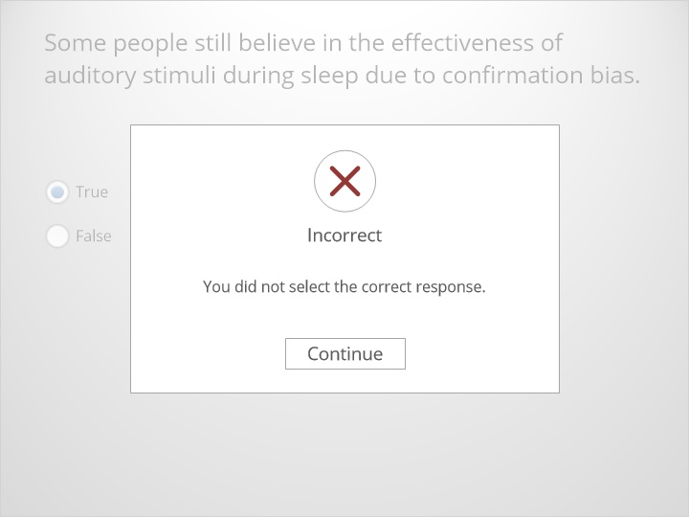

Q1.5 A person may still believe in the effectiveness of auditory stimuli during sleep because of a anecdotal reports and personal experiences supporting its effectiveness.
(True/False, 10 points, 1 attempt permitted)
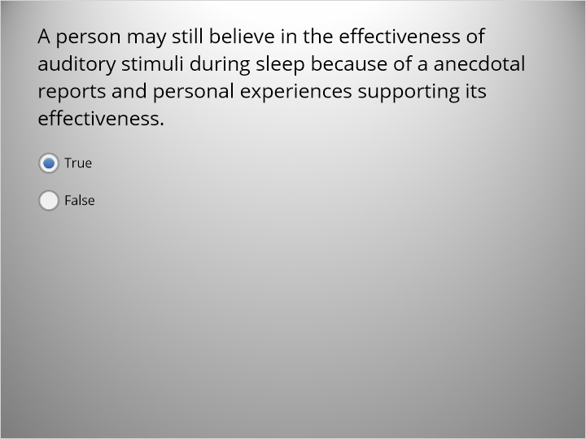
Correct | Choice
X | True
 | False

Feedback when correct:
That's right! You selected the correct response.
Feedback when incorrect:
You did not select the correct response.

Correct (Slide Layer)
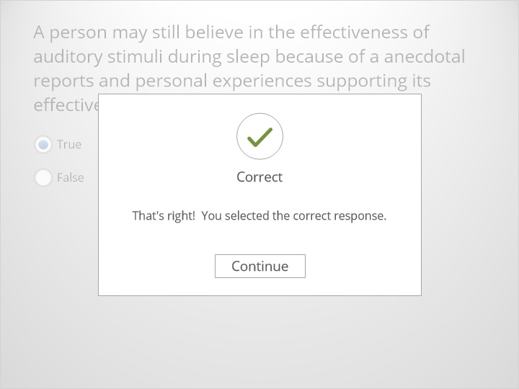

Incorrect (Slide Layer)
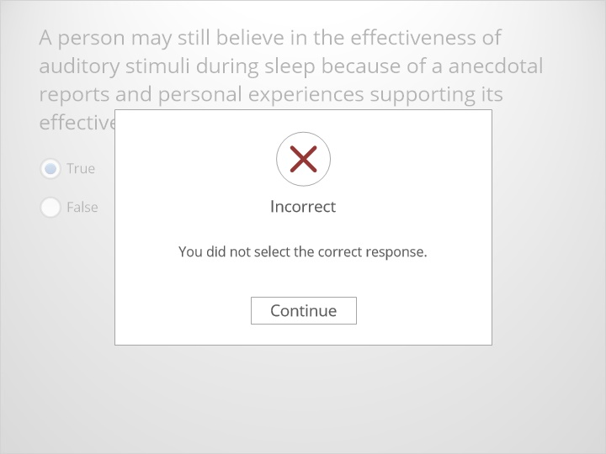

Q1.6 Persons may still believe in the effectiveness of auditory stimuli during sleep because of influence of marketing claims and misinformation.
(True/False, 10 points, 1 attempt permitted)
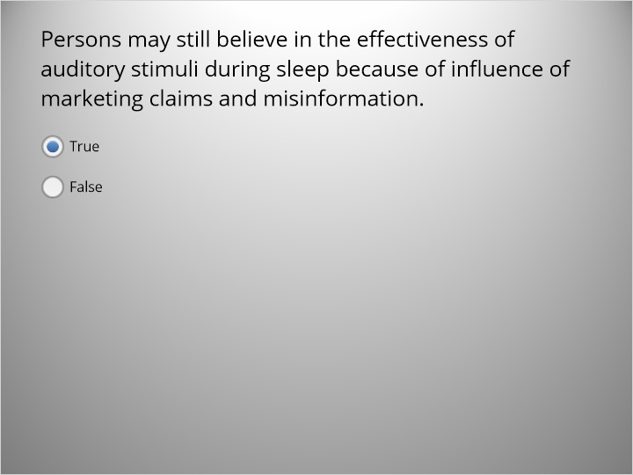
Correct | Choice
X | True
 | False

Feedback when correct:
That's right! You selected the correct response.
Feedback when incorrect:
You did not select the correct response.

Correct (Slide Layer)
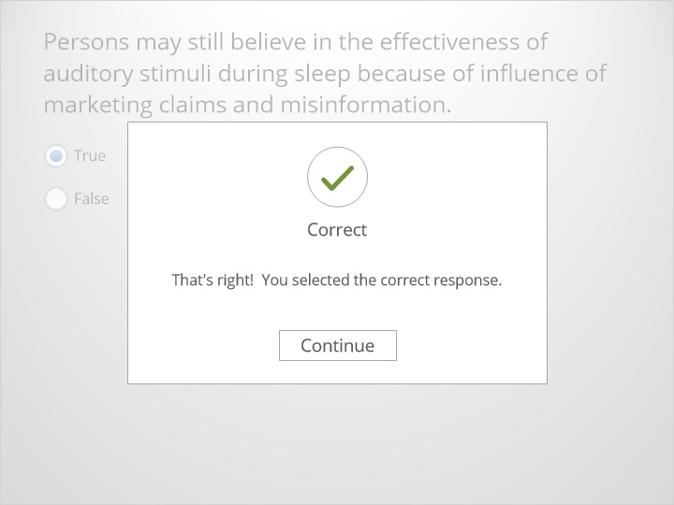

Incorrect (Slide Layer)
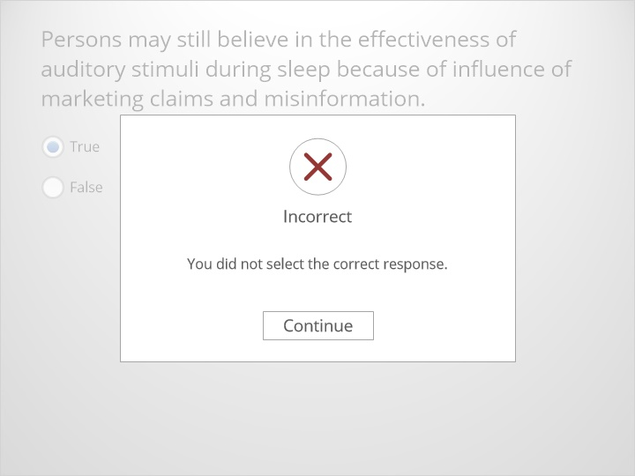

Q1.7 Misinterpretation of inconclusive or preliminary findings may cause people to still believe in the effectiveness of auditory stimuli during sleep.
(True/False, 10 points, 1 attempt permitted)
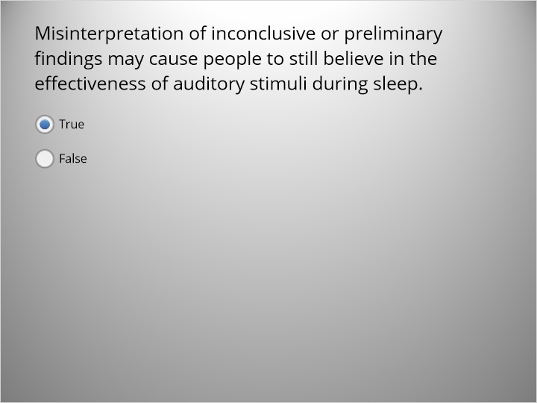
Correct | Choice
X | True
 | False

Feedback when correct:
That's right! You selected the correct response.
Feedback when incorrect:
You did not select the correct response.

Correct (Slide Layer)
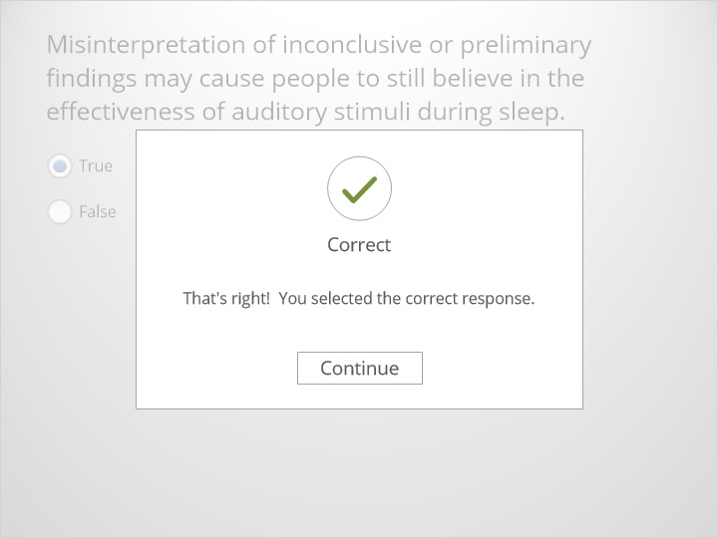

Incorrect (Slide Layer)
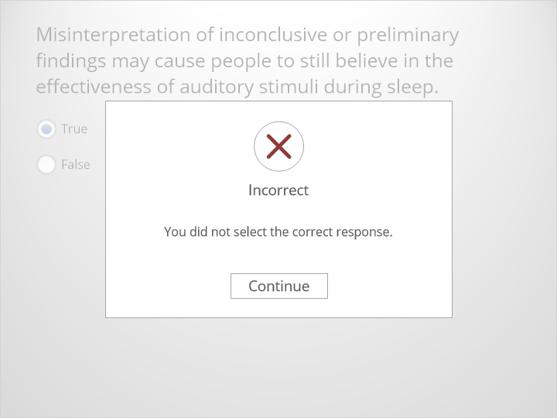

Q1.8 Which part of the brain is involved in decision-making and evaluating the emotional significance of events in dreams?
(Multiple Choice, 10 points, 1 attempt permitted)
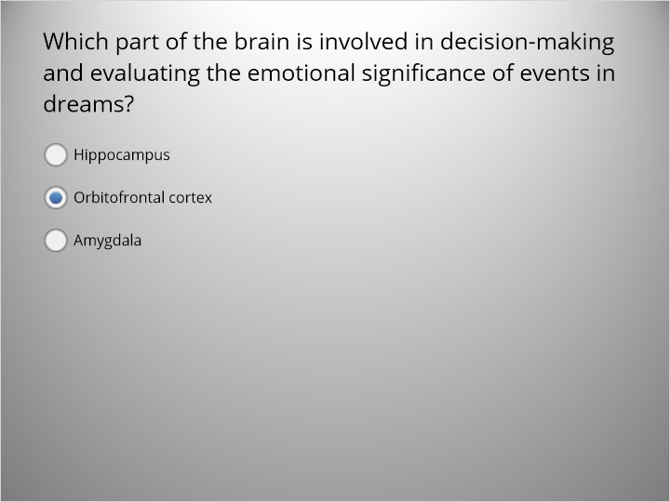
Correct | Choice
 | Hippocampus
X | Orbitofrontal cortex
 | Amygdala

Feedback when correct:
That's right! You selected the correct response.
Feedback when incorrect:
You did not select the correct response.

Correct (Slide Layer)
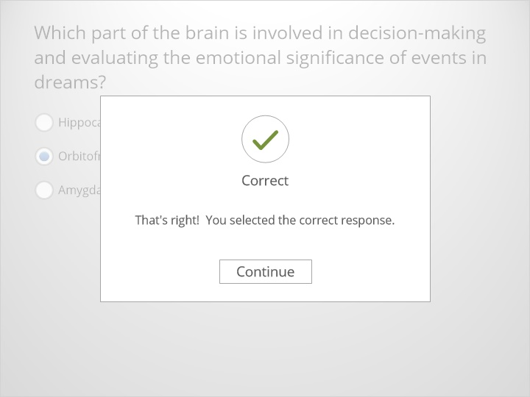

Incorrect (Slide Layer)
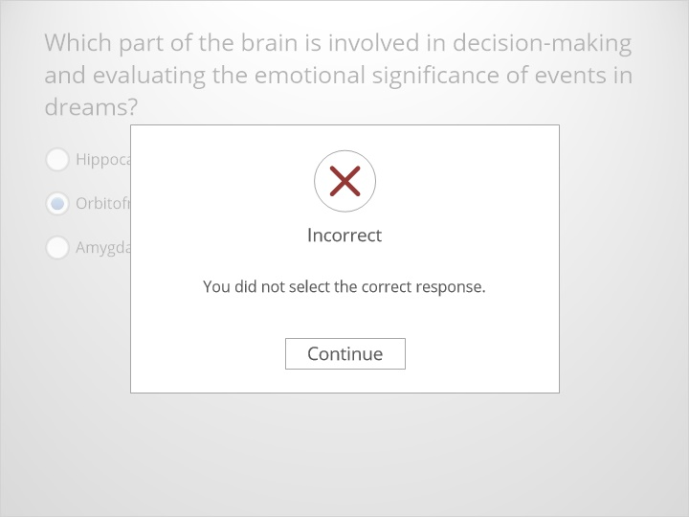

Q1.9 The orbitofrontal cortex remains active during all stages of sleep.
(True/False, 10 points, 1 attempt permitted)
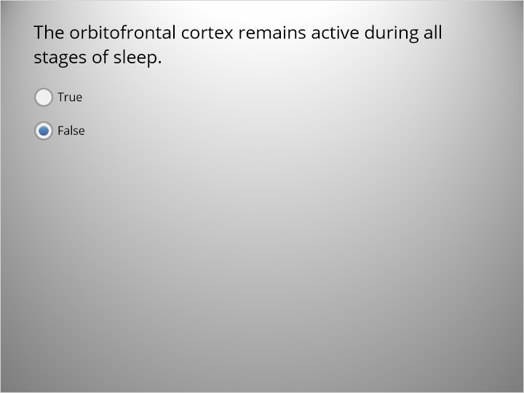
Correct | Choice
 | True
X | False

Feedback when correct:
That's right! You selected the correct response.
Feedback when incorrect:
You did not select the correct response.

Correct (Slide Layer)
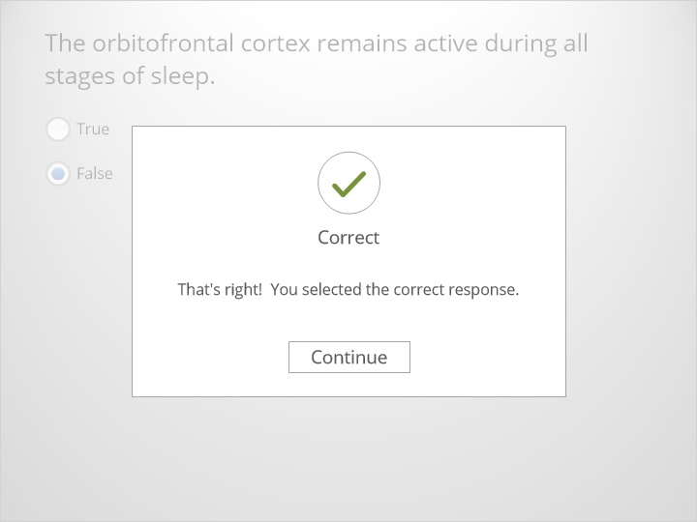

Incorrect (Slide Layer)
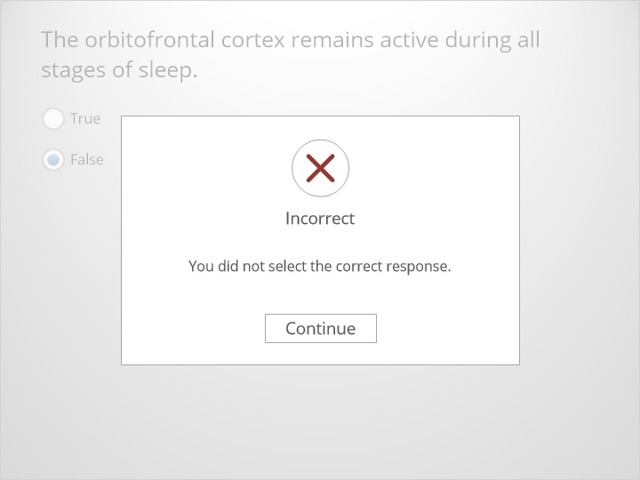

Q1.10 The orbitofrontal cortex contributes to emotional experiences within dreams.
(True/False, 10 points, 1 attempt permitted)
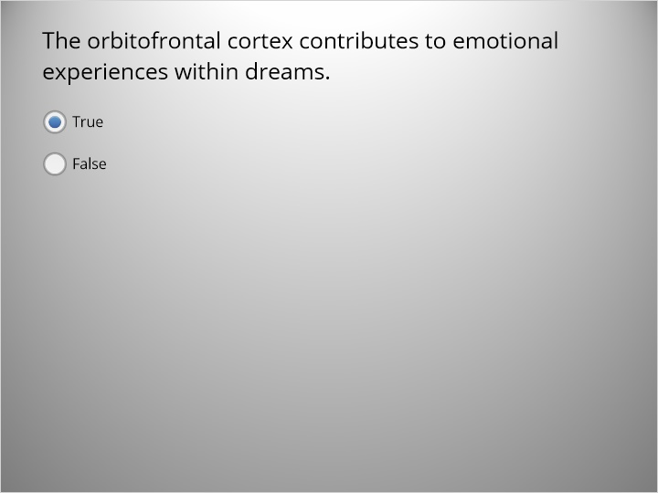
Correct | Choice
X | True
 | False

Feedback when correct:
That's right! You selected the correct response.
Feedback when incorrect:
You did not select the correct response.

Correct (Slide Layer)
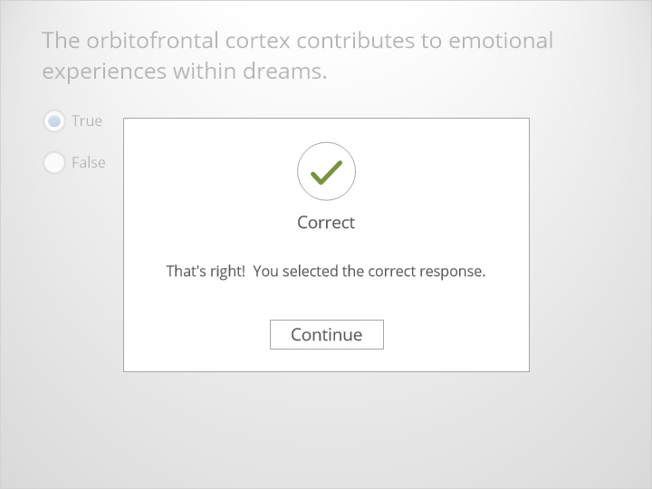

Incorrect (Slide Layer)
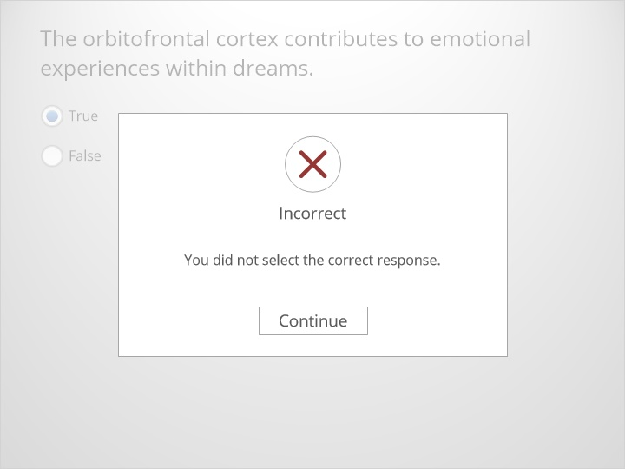

Q1.11 The orbitofrontal cortex is largely inactive during dreaming.
(True/False, 10 points, 1 attempt permitted)
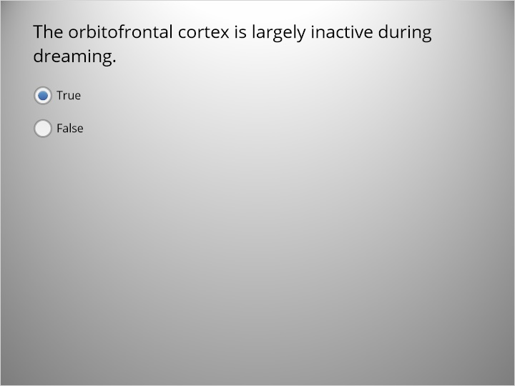
Correct | Choice
X | True
 | False

Feedback when correct:
That's right! You selected the correct response.
Feedback when incorrect:
You did not select the correct response.

Correct (Slide Layer)
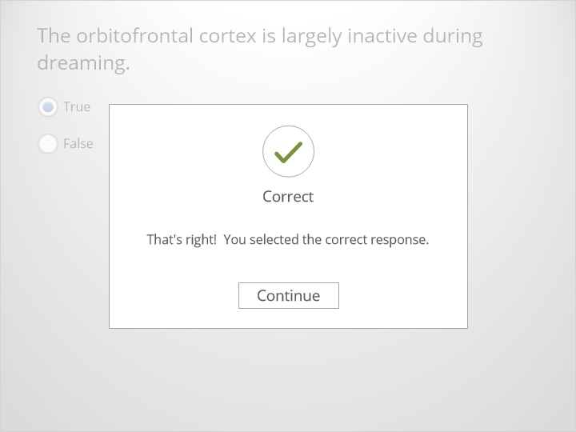

Incorrect (Slide Layer)
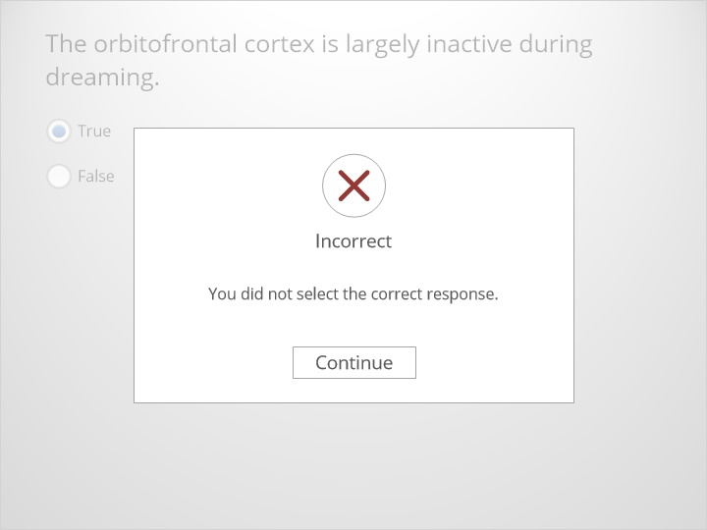

Q1.12 What is the primary function of the orbitofrontal cortex?
(Multiple Choice, 10 points, 1 attempt permitted)
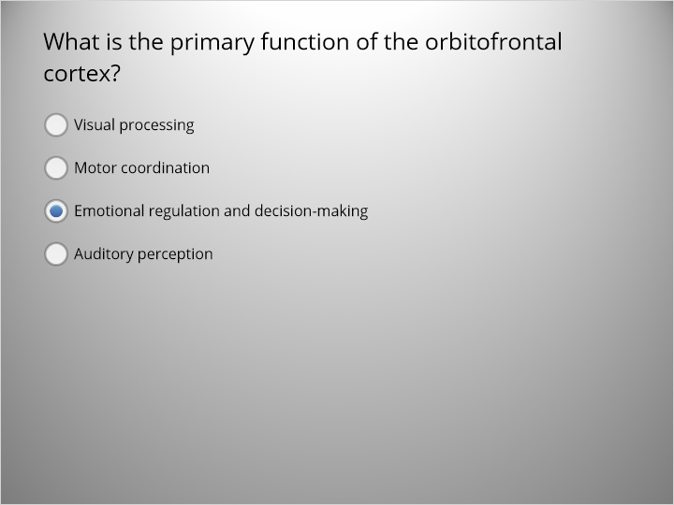
Correct | Choice
 | Visual processing
 | Motor coordination
X | Emotional regulation and decision-making
 | Auditory perception

Feedback when correct:
That's right! You selected the correct response.
Feedback when incorrect:
You did not select the correct response.

Correct (Slide Layer)
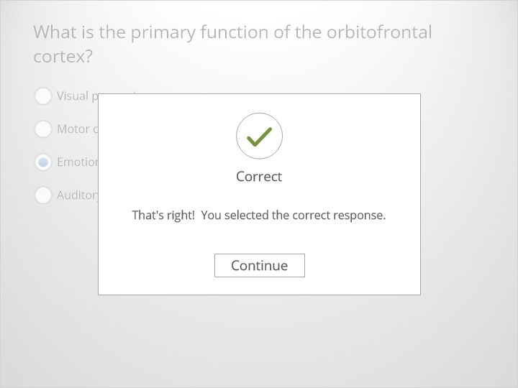

Incorrect (Slide Layer)
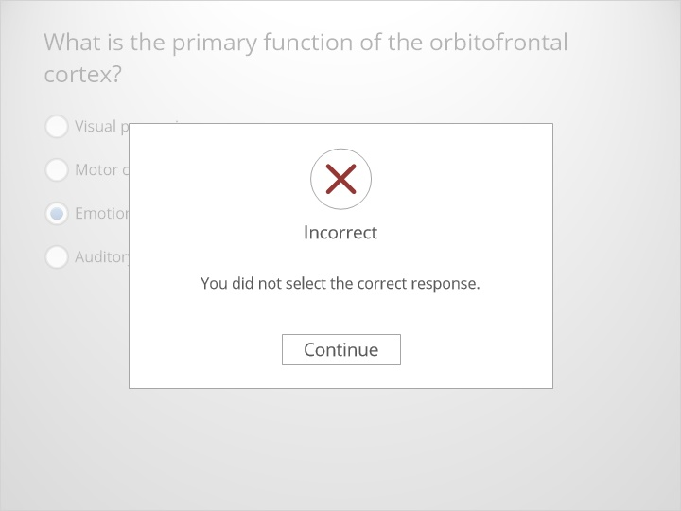

Q1.13 During sleep, the prefrontal cortex and orbitofrontal cortex are very active.
(True/False, 10 points, 1 attempt permitted)
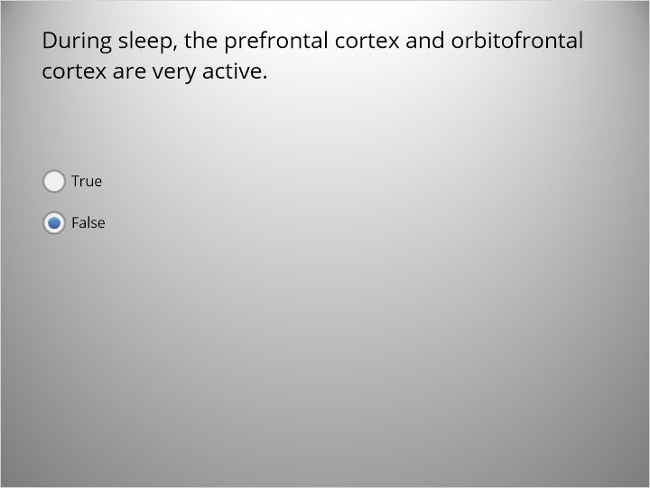
Correct | Choice
 | True
X | False

Feedback when correct:
That's right! You selected the correct response.
Feedback when incorrect:
You did not select the correct response.

Correct (Slide Layer)
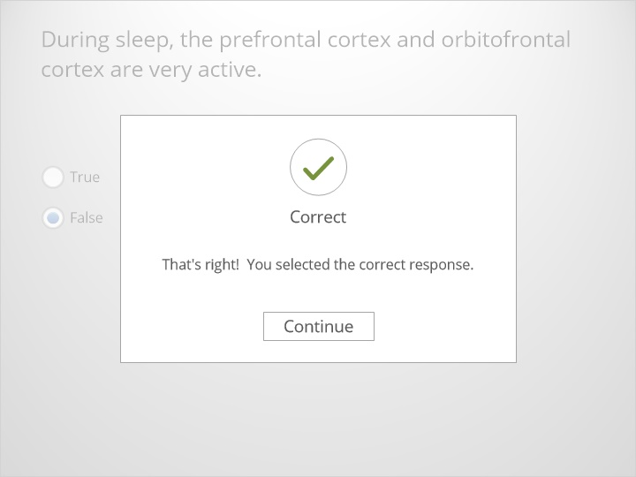

Incorrect (Slide Layer)
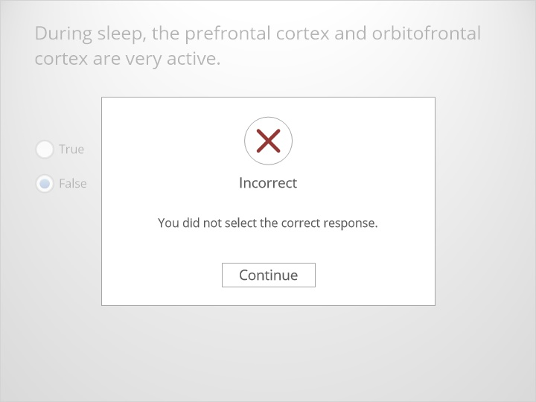

Q1.14 Which brain region is typically less active during sleep, contributing to reduced cognitive processing and decision-making abilities?
(Multiple Choice, 10 points, 1 attempt permitted)
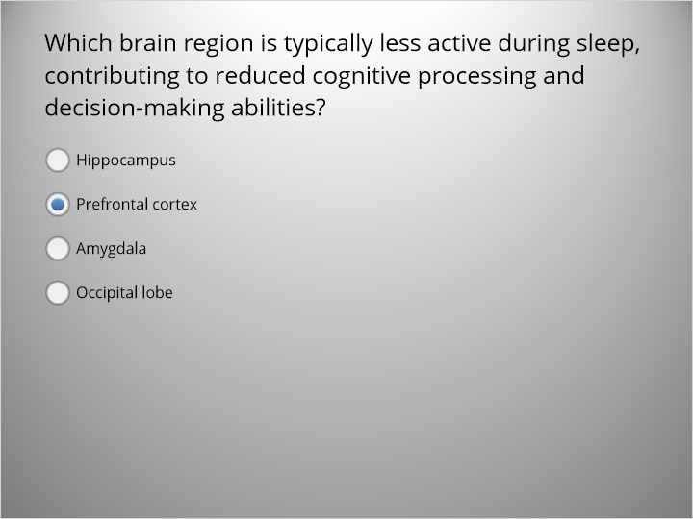
Correct | Choice
 | Hippocampus
X | Prefrontal cortex
 | Amygdala
 | Occipital lobe

Feedback when correct:
That's right! You selected the correct response.

Correct (Slide Layer)
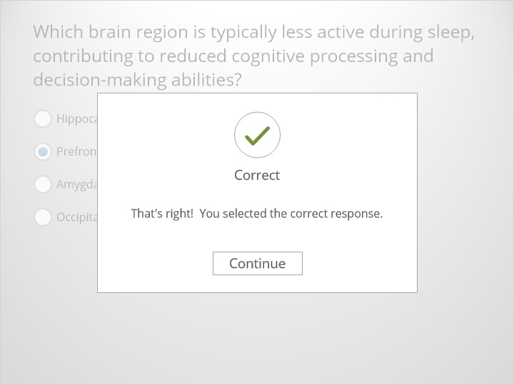

Incorrect (Slide Layer)
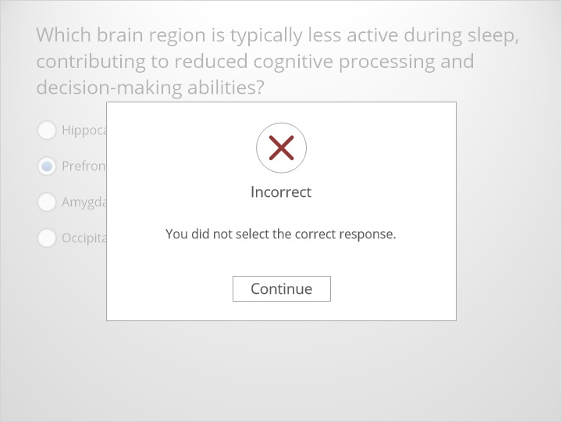

Q1.15 Auditory stimuli during sleep can significantly enhance memory consolidation.
(True/False, 10 points, 1 attempt permitted)
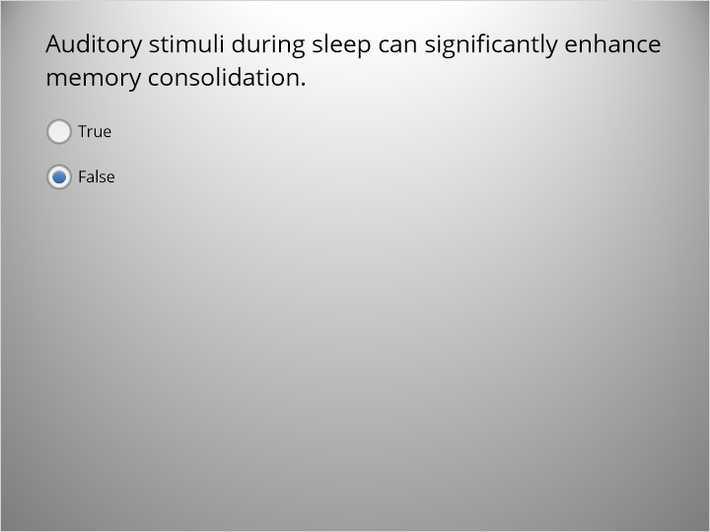
Correct | Choice
 | True
X | False

Feedback when correct:
That's right! You selected the correct response.
Feedback when incorrect:
You did not select the correct response.

Correct (Slide Layer)
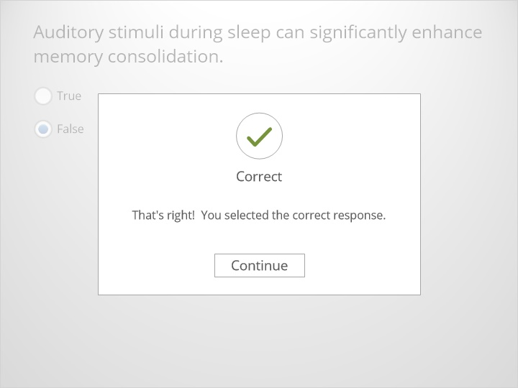

Incorrect (Slide Layer)
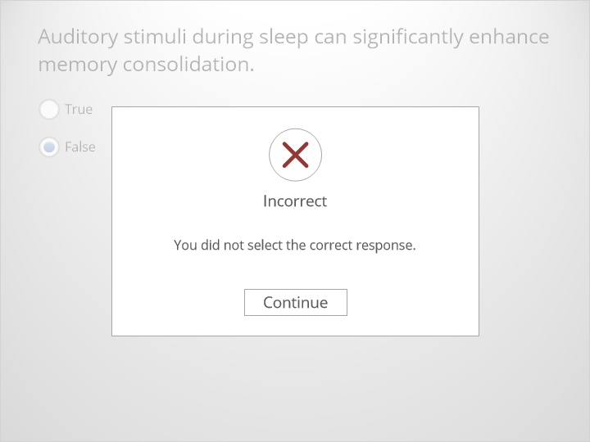

Q1.16 The brain's response to auditory stimuli during sleep is similar to wakefulness.
(True/False, 10 points, 1 attempt permitted)
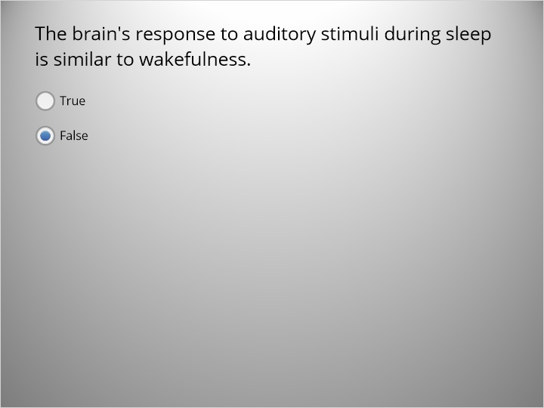
Correct | Choice
 | True
X | False

Feedback when correct:
That's right! You selected the correct response.
Feedback when incorrect:
You did not select the correct response.

Correct (Slide Layer)
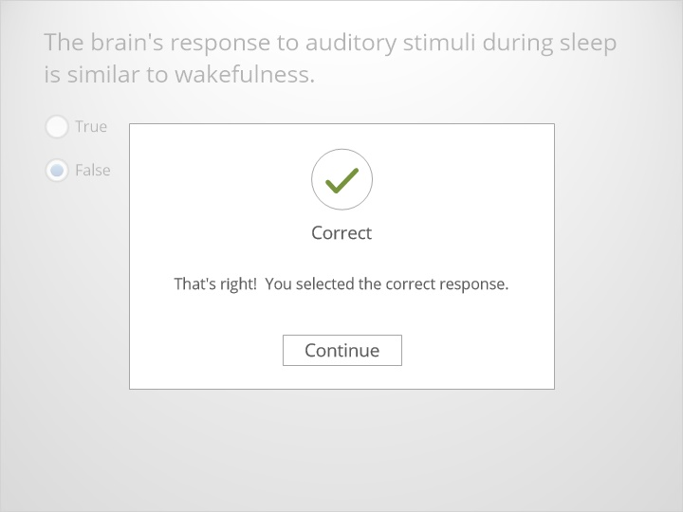

Incorrect (Slide Layer)
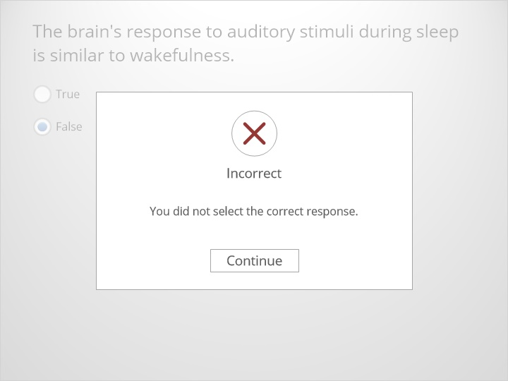

Q1.17 Some memory consolidation may occur during sleep.
(True/False, 10 points, 1 attempt permitted)
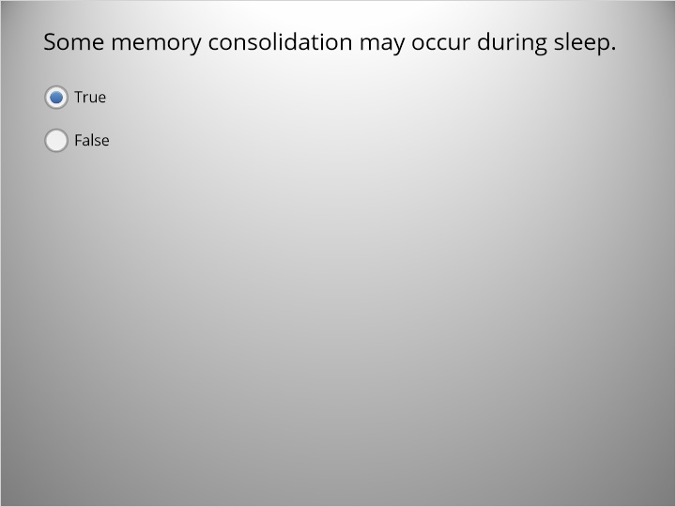
Correct | Choice
X | True
 | False

Feedback when correct:
That's right! You selected the correct response.
Feedback when incorrect:
You did not select the correct response.

Correct (Slide Layer)
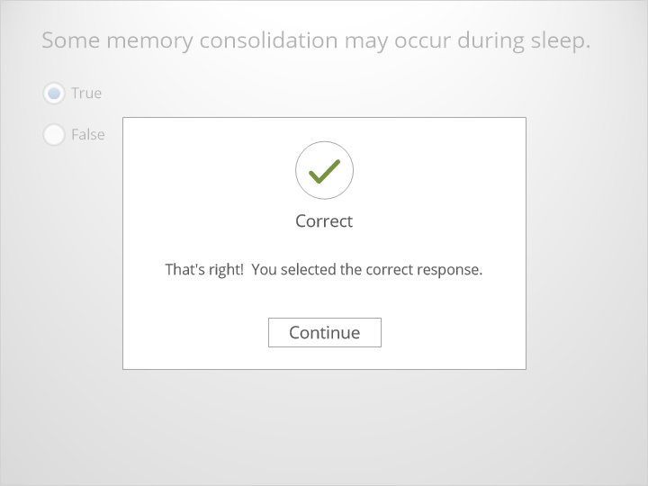

Incorrect (Slide Layer)
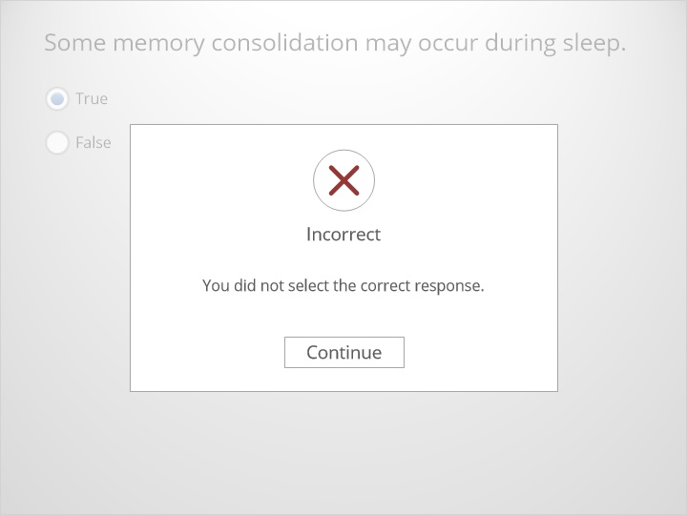

Q1.18 Aspects of contextual learning are prevalent when listening to audio while asleep.
(True/False, 10 points, 1 attempt permitted)
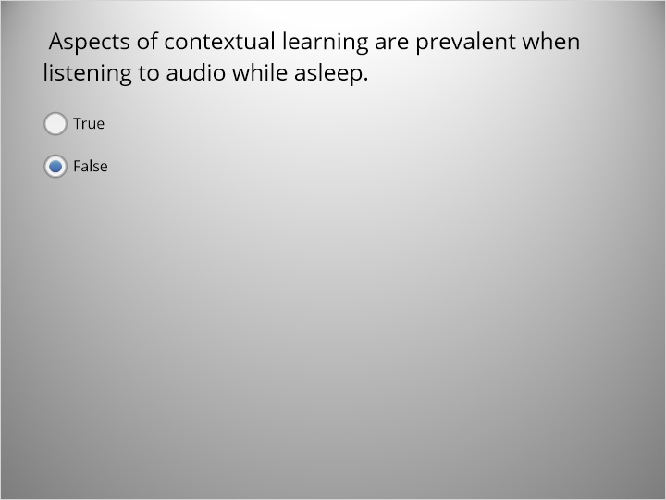
Correct | Choice
 | True
X | False

Feedback when correct:
That's right! You selected the correct response.
Feedback when incorrect:
You did not select the correct response.

Correct (Slide Layer)
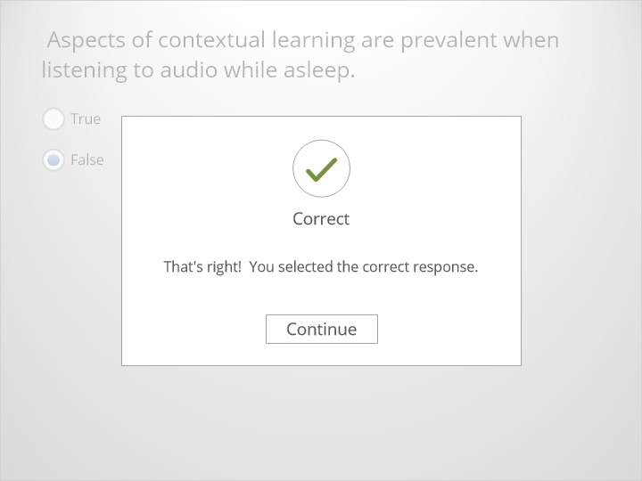

Incorrect (Slide Layer)
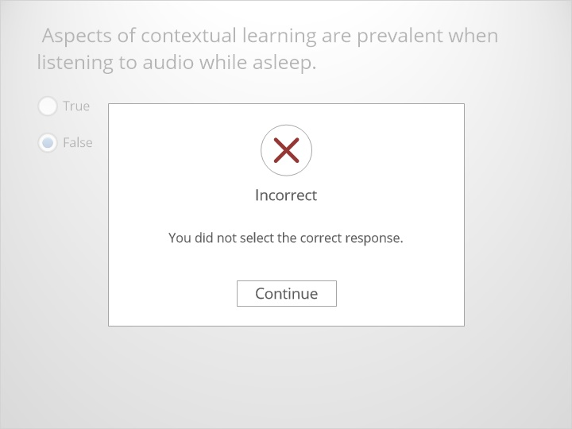

Q1.19 While sleeping, the brain actively processes and integrates auditory stimuli with existing knowledge and experiences.
(True/False, 10 points, 1 attempt permitted)
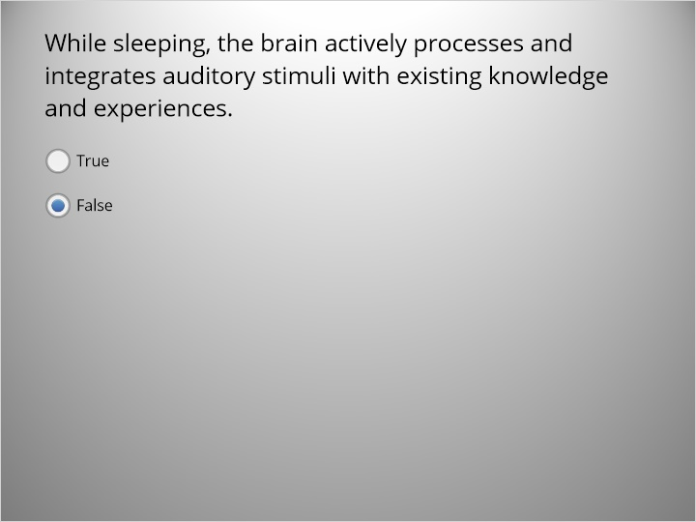
Correct | Choice
 | True
X | False

Feedback when correct:
That's right! You selected the correct response.
Feedback when incorrect:
You did not select the correct response.

Correct (Slide Layer)
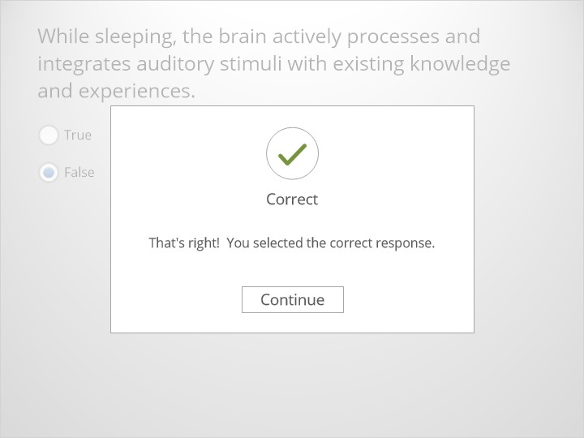

Incorrect (Slide Layer)
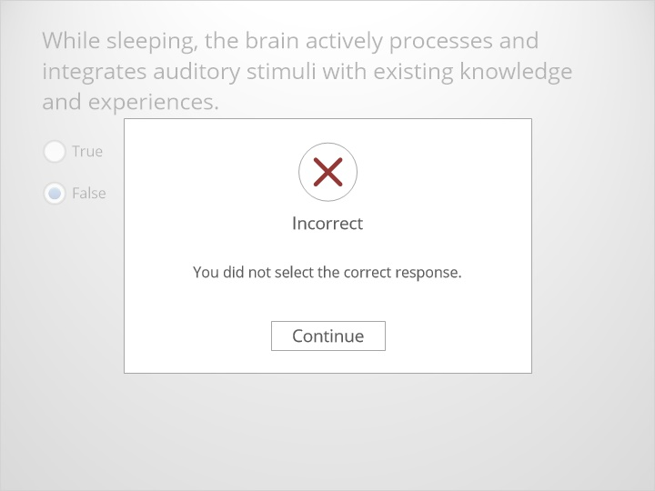

Q1.20 Contextual learning means understanding context, making connections, and engaging with the material.

(True/False, 10 points, 1 attempt permitted)
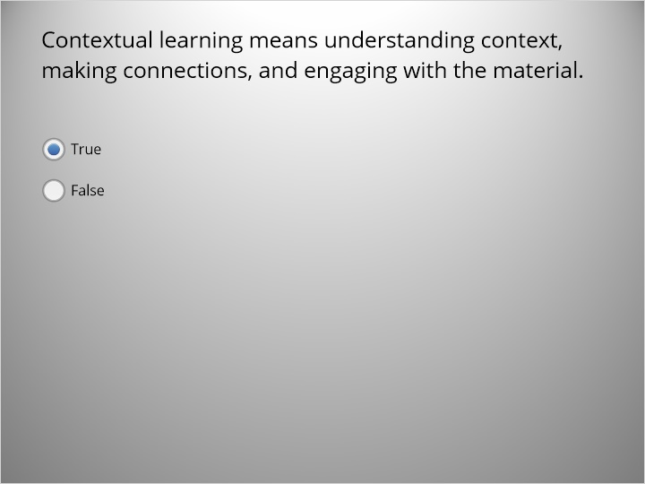
Correct | Choice
X | True
 | False

Feedback when correct:
That's right! You selected the correct response.
Feedback when incorrect:
You did not select the correct response.

Correct (Slide Layer)
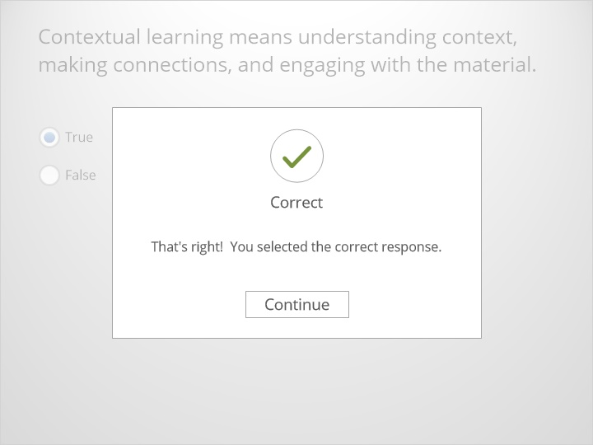

Incorrect (Slide Layer)
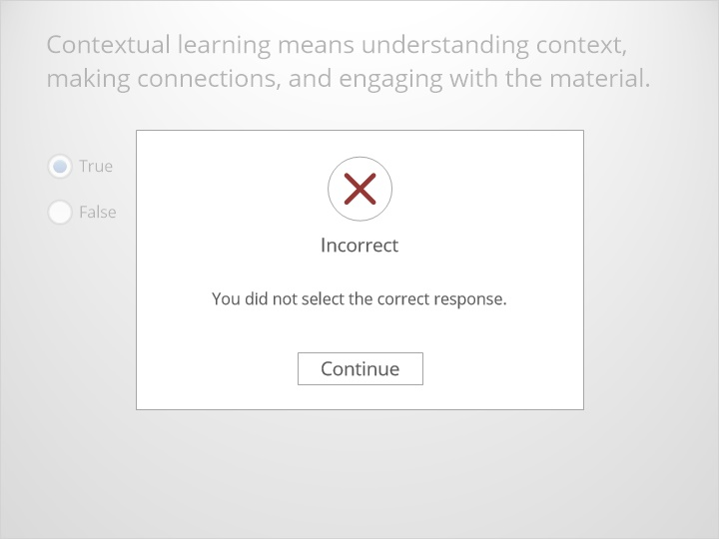

Q1.21 Engaging with material, making connections, and understanding context are often lacking when listening to audio while asleep.
(True/False, 10 points, 1 attempt permitted)
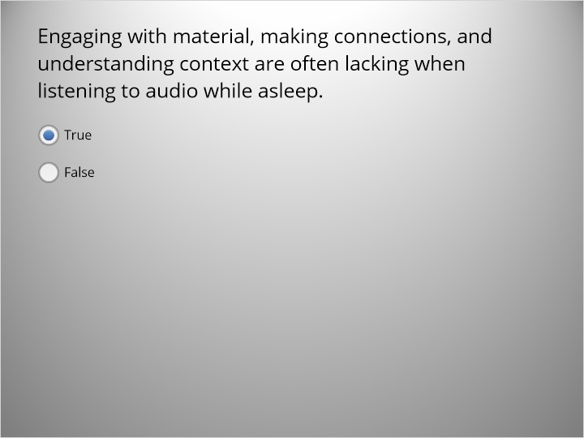
Correct | Choice
X | True
 | False

Feedback when correct:
That's right! You selected the correct response.
Feedback when incorrect:
You did not select the correct response.

Correct (Slide Layer)
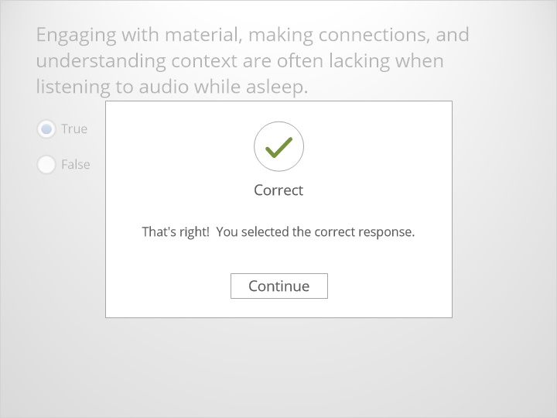

Incorrect (Slide Layer)
